Year 12 ATAR PHYSICS
Practical Test WAVES AND QUANTA

Part B: DETERMINING THE EFFECTIVE WAVELENGTH OF A LED.

Marks: /10

Name: __________________________ Teacher: ________________________

The threshold voltage at which a semiconductor LED turns on gives a measure of the bandgap or emission wavelength of the LED through the following relationship:
The following circuit was constructed:
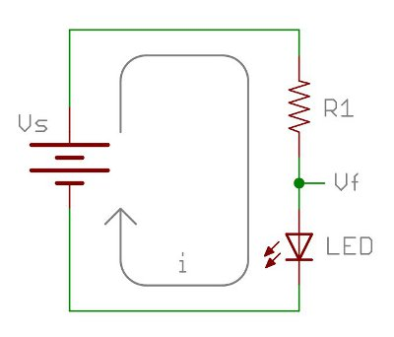
V
100 Ω resistor

50K Rheostat
A
By adjusting the rheostat, the following values of current and voltage through the LED was recorded:
V(V) | I(mA)
2.40 | 0.12
2.43 | 0.40
2.44 | 0.50
2.48 | 0.97
2.50 | 1.20

Question 1
Plot a suitable graph of the results. ( 4 marks)

Question 2 ( 3 marks)
Determine the threshold voltage from the graph. Clearly show your method on the graph.
Your answer should be to the maximum number of significant figures possible.

V_{th} = __________________________________________

Question 3 ( 3 marks)
Determine the wavelength of the LED in nanometres.

